Camp Grier Drop off & Pick Up

(if your child is traveling to camp with their sponsor please refer to the details in their separate email)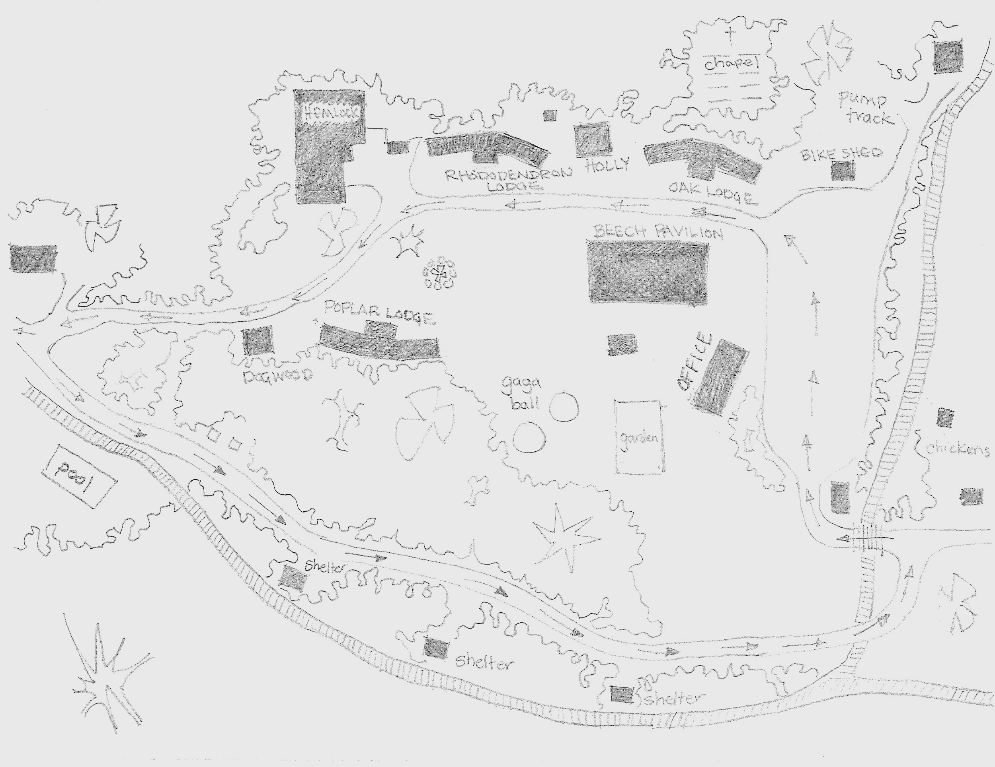

Sunday Arrival
- Adventurers and Navigator groups (middle and high school ages) arrive from 1pm to 2pm
- Explorer and Discover groups (elementary age) arrive from 2pm to 3pm
- If you have children from both ages please arrive between 1pm and 2pm.
Over the past two summers camps have found that a drive through drop off works best for children at camp. Anxiety and homesickness were greatly decreased even in these difficult times. A quick goodbye allows your child to adjust and settle in the easiest. So we will continue to stagger arrival time in order to manage the traffic and ask that you remain near your vehicle for a quick goodbye with only staff and campers allowed in buildings prior to the start of a session. Any medications will be turned in at the registration tent. Please have them available. Luggage will be dropped off at the front porch of their cabin or in the group’s luggage bin. After saying goodbye to parents, campers will walk through the health screening area for a lice check prior to moving belongings into the cabins.
We will have a stand set up outside the main gate where you can drop off letters for your camper to be delivered at camp on the day of your choice. We will also be selling our produce, eggs and plants at both pick up and drop off.
Tip: Keep cool on your way to camp. Standing in the sun for photos just before screening can cause temperatures to read higher. If you don’t have AC in the car, it helps to take a break in the shade prior to screening.

Friday Departure
- All campers should be picked up between 10am and 11:30am. We ask that you are departing by 11:30 so that we can begin our weekly staff lunch and debriefing meeting on time.
We love seeing families at camp and feel that Friday is the best day to have your child give you a tour of camp. You will have the opportunity to purchase camp keepsakes as well as pick up fresh eggs, honey or produce from our farm. Medications will be picked up under Beech Pavilion. Campers and luggage will be picked up at their cabin or the luggage rack. Photos from the week will be sent via email for you to continue to enjoy the stories of the week with your child at home.

